1. STATICS
FORCE: It requires Magnitude, direction and point of application.
RESOLUTION OF FORCES: If a force makes angle with X axis then,
The $cosine$ component will be along X axis. | The $sine$ component will be along Y axis.
THEOREM OF TRANSMISSIBILITY: Force can be shifted along it’s line of action without changing It’s effect.

MOMENT: $\vec{M}=\vec{R}×\vec{P}$. | Clockwise Considered $-ve$ | Anti-Clockwise Considered $+ve$
- Use Right hand thumb rule to determine the direction of moment.
- Moment value on any point on line of action of force is zero.
THEOREM OF VARIGNON:
Moment of a force about a point is same as moment vector addition of component of force about the same point.
COUPLE: Two Equal and opposite force separated by some distance creates couple.
$$M=Force* ⊥distance$$ | It can’t produce translation effect.
It can only produce rotational effect. | It can be only balanced by another equal and opposite couple.

TYPES OF FORCES
COPLANAR | PARALLEL | CONCURRENT
All Forces are in one plane. | Forces are parallel to each other | Forces Passing through single point

EQUILIBRIUM CONDITIONS
$$\sum{F_{x}}=0$$ | $$\sum{F_{y}}=0$$ | $$\sum{F_{z}}=0$$ | $$\sum{M_{x}}=0$$ | $$\sum{M_{y}}=0$$ | $$\sum{M_{z}}=0$$
For Co-Planar forces there are 3 equations only for equilibrium condition.
EQUILIBRIUM OF TWO FORCES: Two forces can be in equilibrium if they are,
Equal in magnitude | Opposite in direction | Colinear

RESULTANT OF TWO FORCES: Resultant force is obtained when two forces are not in equilibrium condition.  PARALLELOGRAM LAW:  $$\vec{R}=\vec{A}+\vec{B}=\left(A+B\cos{θ}\right)\hat{i}+B\sin{θ}\hat{j}$$  $$\left|\vec{R}\right|=\sqrt{A^{2}+B^{2}+2AB\cos{θ}},\tan{β}={\left(B\sin{θ}\right)}/{\left(A+B\cos{θ}\right)}$$ | 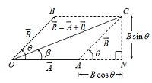 | COSINE RULE: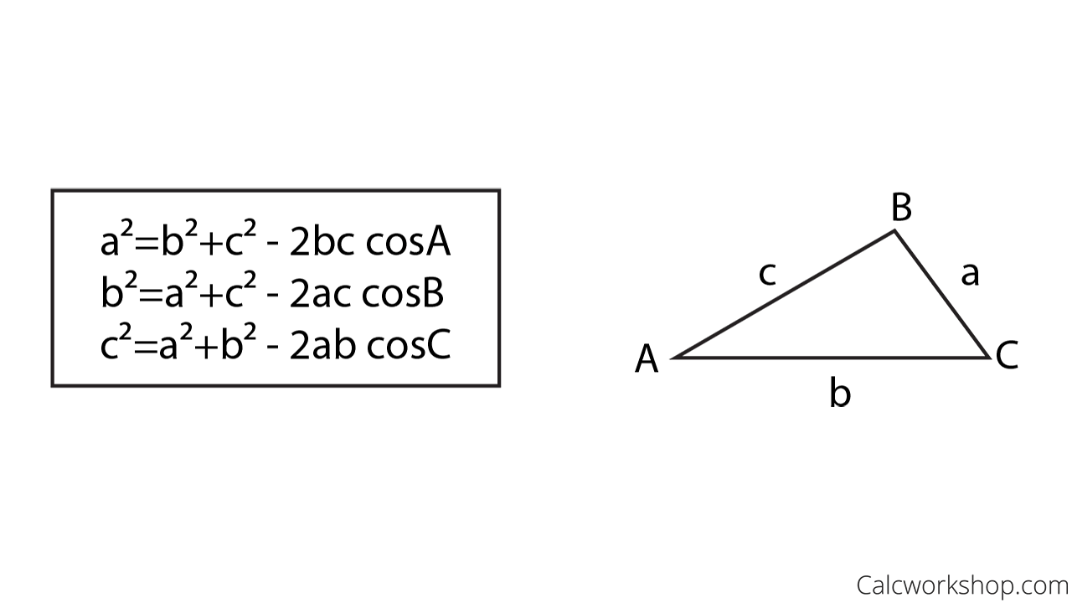

 | Like Forces | Unlike Forces | $$\vec{A}⊥\vec{B}$$ | $$\vec{R}⊥\vec{A}$$
$$θ$$ | $$0°$$ | $$180°$$ | $$90°$$ | $$>90°$$
$$\left|\vec{R}\right|$$ | $$A+B=Max Value$$ | $$A-B=Min Value$$ | $$\left|\vec{R}\right|=\sqrt{A^{2}+B^{2}}$$ | $$R=B\sin{θ}\&P=-Q\cos{θ}$$
$$β$$ | $$0°$$ | $$either 0° or 180°$$ | $$\tan^{-1}\left(B/A\right)$$ | $$90°$$

RESULTANT OF COPLANAR FORCE SYSTEM | $$R=\sqrt{{\left(\sum{F_{x}}\right)}^{2}+{\left(\sum{F_{y}}\right)}^{2}}$$ | $$\tan{β}=\frac{F_{y}}{F_{x}}$$
CONDITION FOR EQUILIBRIUM OF 3 FORCES:
1) Co-Planar, 2) Concurrent, 3) Polygon must be a closed triangle
LAMI’S THEOREM/ SINE RULE:  It’s valid for 3 forces are in equilibrium | $$\frac{P}{\sin{α}}=\frac{Q}{\sin{β}}=\frac{R}{\sin{γ}}=Constant$$

TYPES OF JOINTS OR SUPPORTS
ROLLER SUPPORT | PIN OR HINGE SUPPORT | FIXED SUPPORT
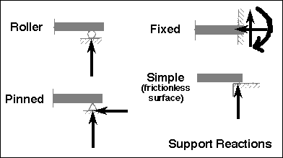 |  | 
Above Arrow signs indicates the Possible opposite reactions.
FREE BODY DIAGRAMS (FBD):  - Weight of The Part  - External Force on The Body  - Support Reactions  - Normal Reaction  - Frictional Force  - Inertia Force | TOTAL SYSTEM FREE BODY DIAGRAMS (FBD):  - Weight of The Parts  - External Forces  - Support Reactions  - Normal Reaction  - Frictional Force  - Inertia Forces  - No Internal Forces
TENSILE FORCE: Show tension towards the other end.

